**Daily Scrum or Standup Meeting**

Team name: __Group 10_______________________

Scrum Master: __Tanner Hooper_____________________

Date:__4-2-19_____________________________

|  |  |  |  |
| --- | --- | --- | --- |
| **Team Member** | **What did you do since the last scrum?** | **What do you plan to do before the next scrum?** | **What obstacles do you have?** |
| George |  |  |  |
| Zach | Researched Testing and reviewed PR’s | Work on unit testing, and look into how to send emails with python | Might need a gmail account or some kind of smtp server. |
| Tanner | Fixed a URL/navigation bug | Create the borrow model. Maybe do the borrow request. | Need to research ways to do the borrow request. |
| Nick | Built unit tests for movie model and added page edit to user settings. | Help others finish tasks and preforms code reviews | Could be difficult to verify code. For things I have never done before. |
|  |  |  |  |

# Burndown

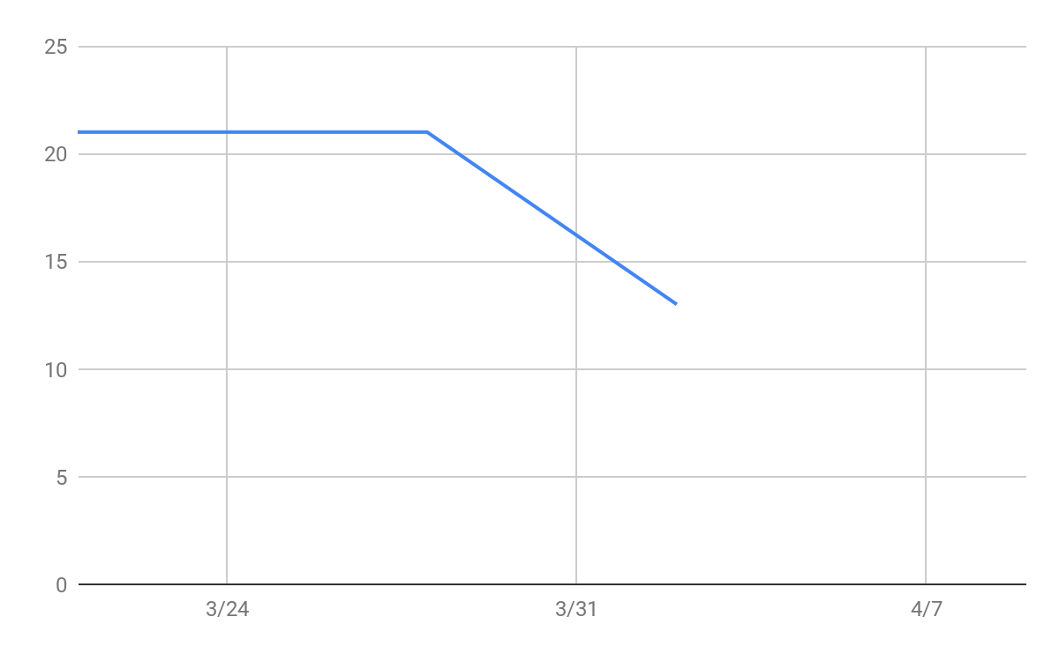

# Screenshot of you task board

